RESTful Web Service IIS Version 6.0 (Build 6002: Service Pack 2) Setup:

* Stie Bindings

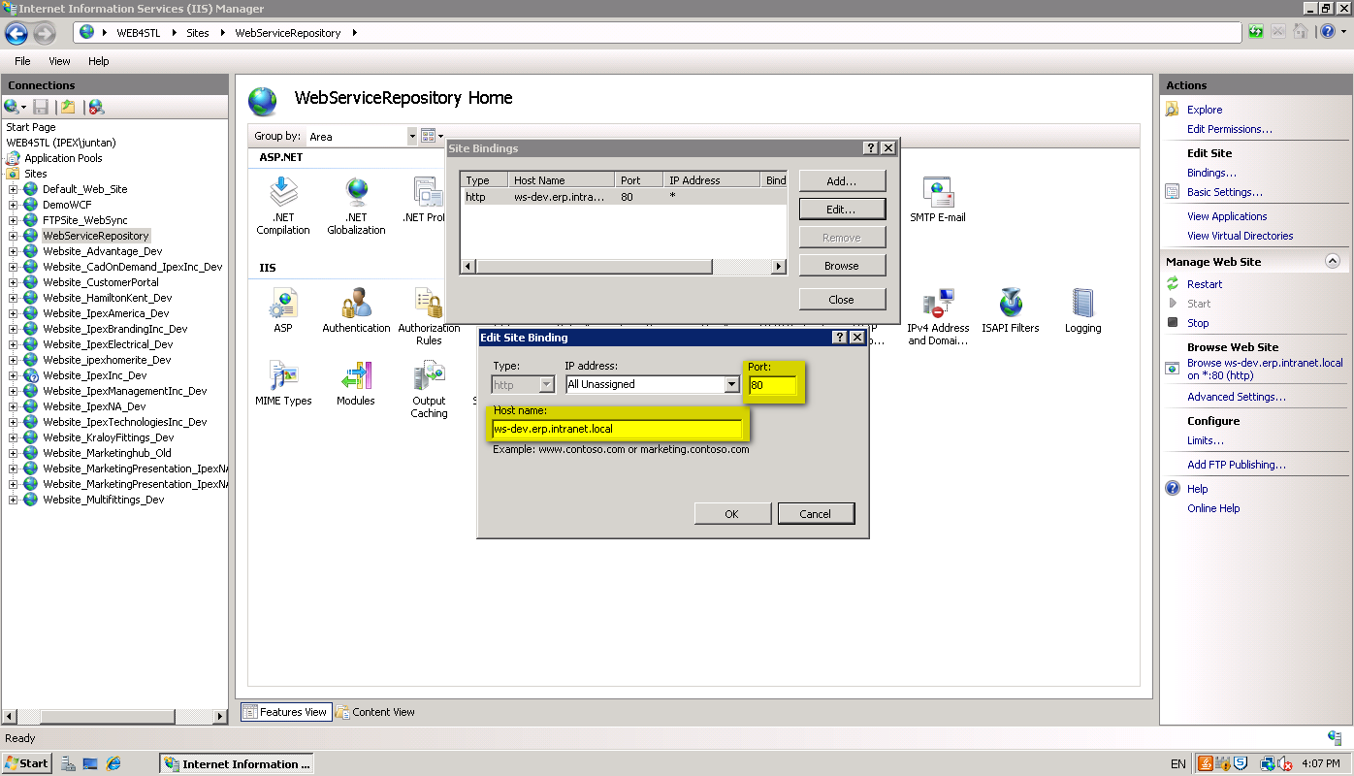

* Basic Settings (Make sure to select DefaultAppPool and it should use .Net Framework Version: 4.0, uninstall .Net framework v4.0 and reinstall it again if it is not the right version, normally this is due to the fact that .Net framework v4.0 was installed prior to IIS)

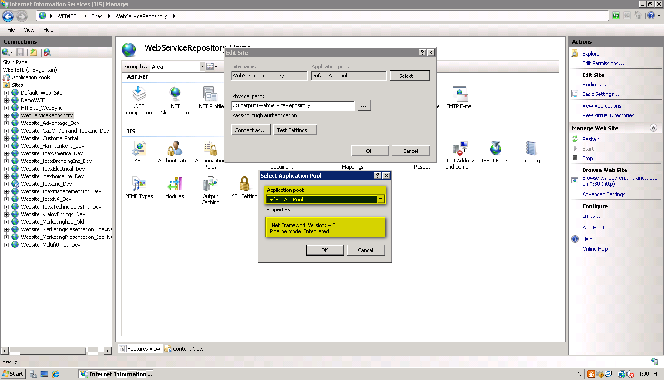

* Authentication

